Answer for Question 1:

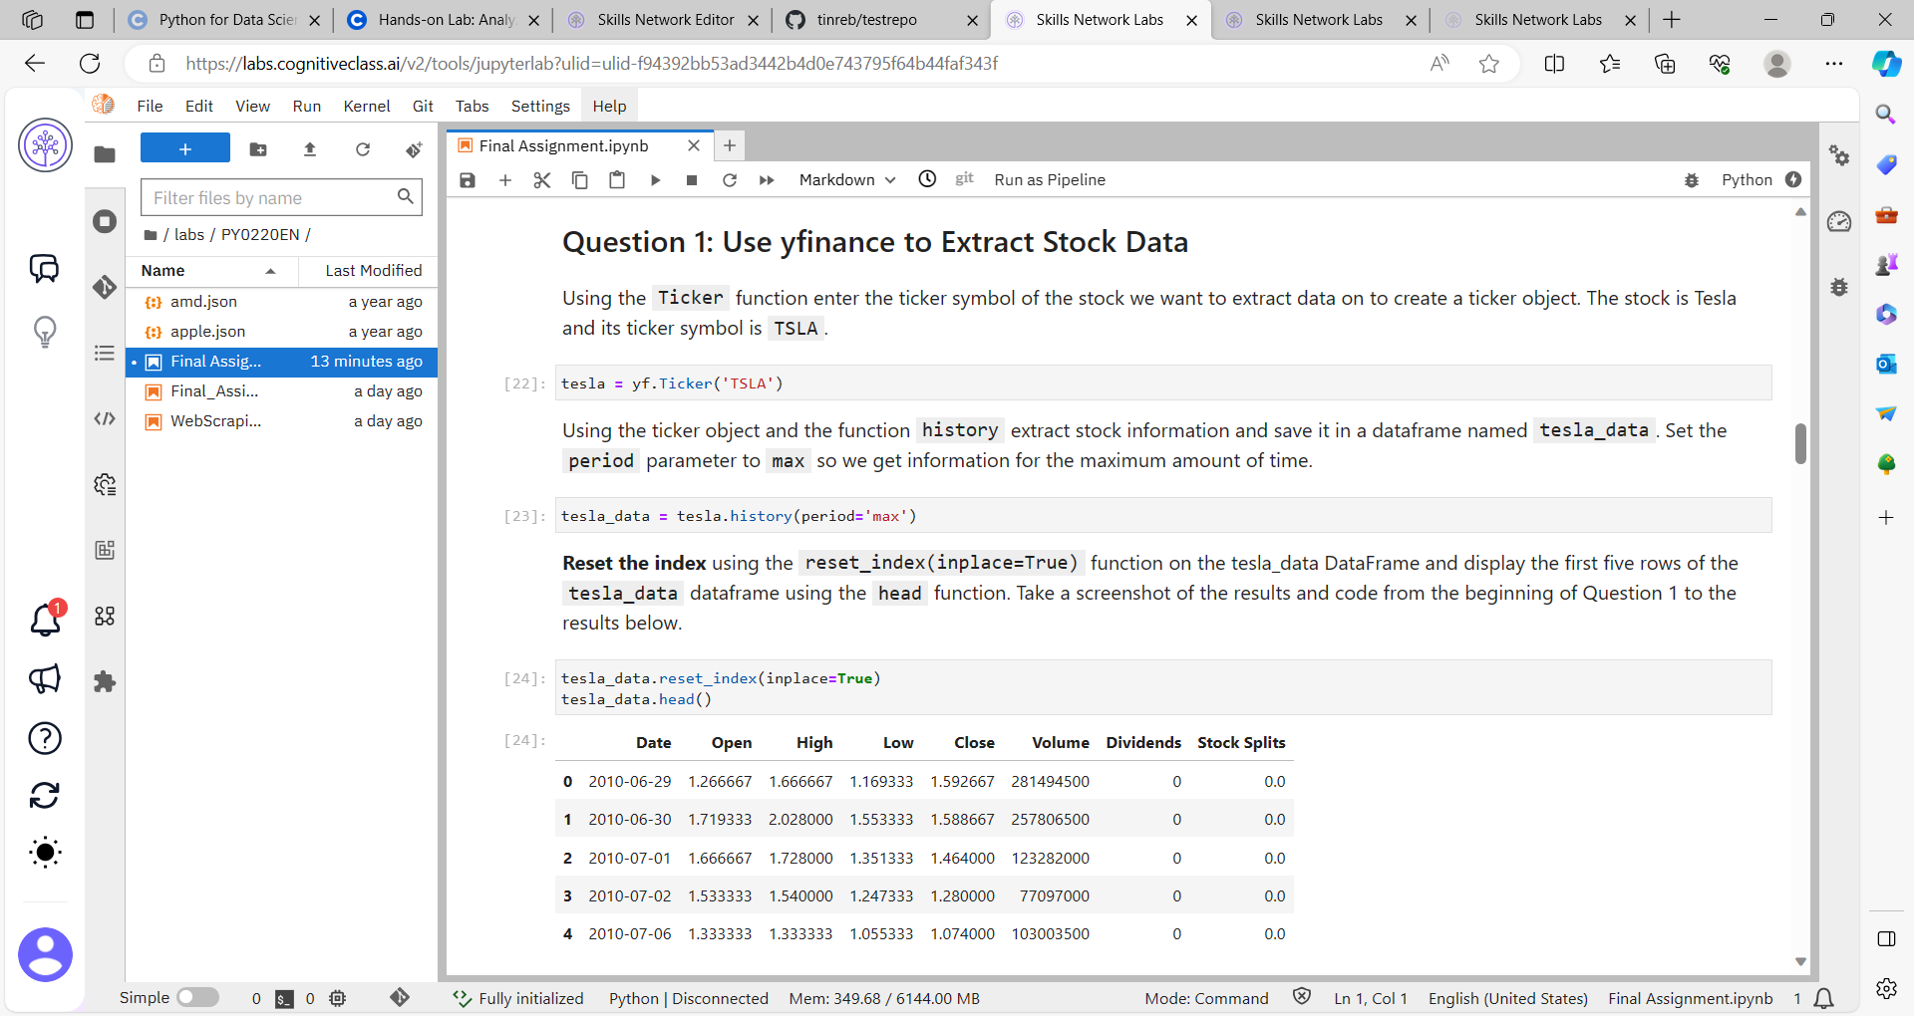

Answer for Question 2: Part 1

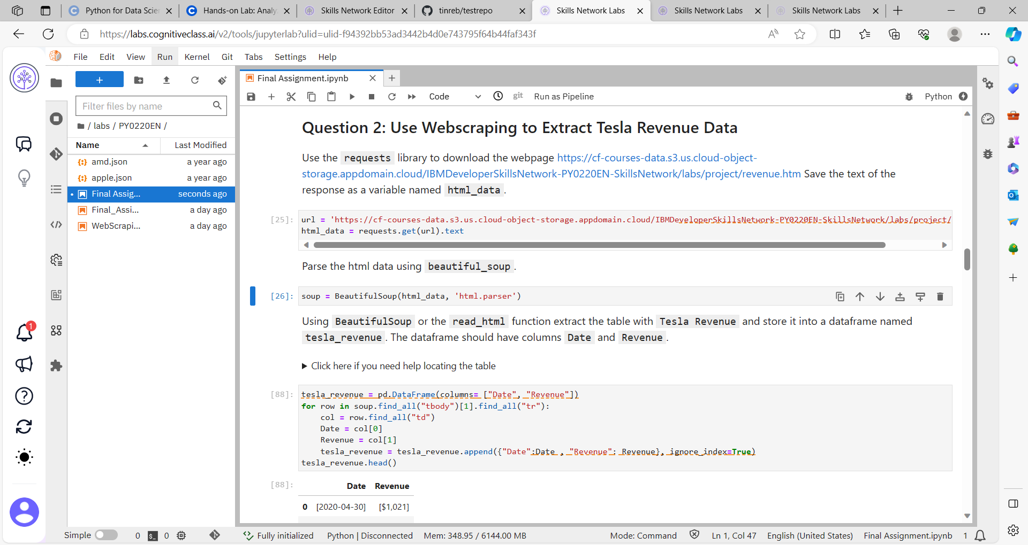

Answer for question 2: Part 2

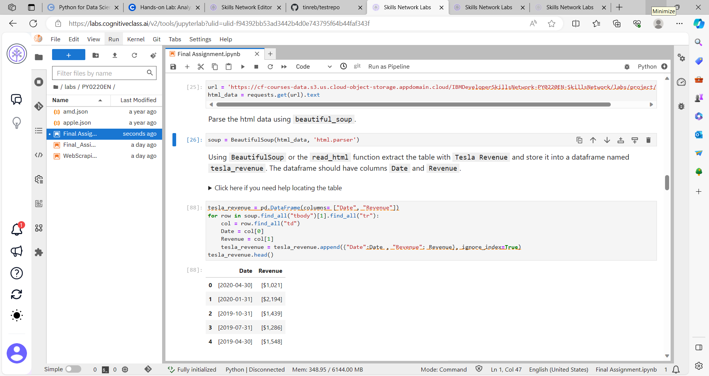

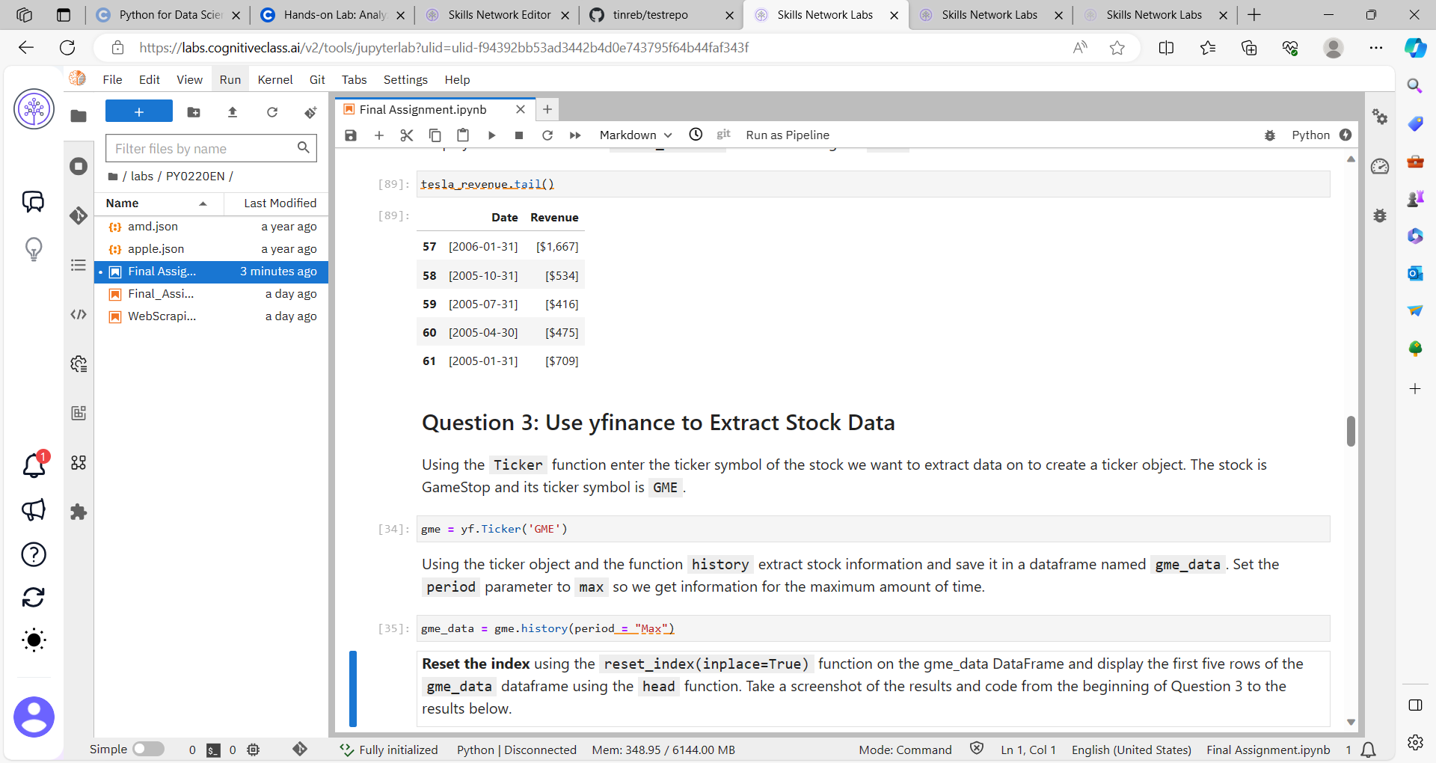

Answer for Question 3:

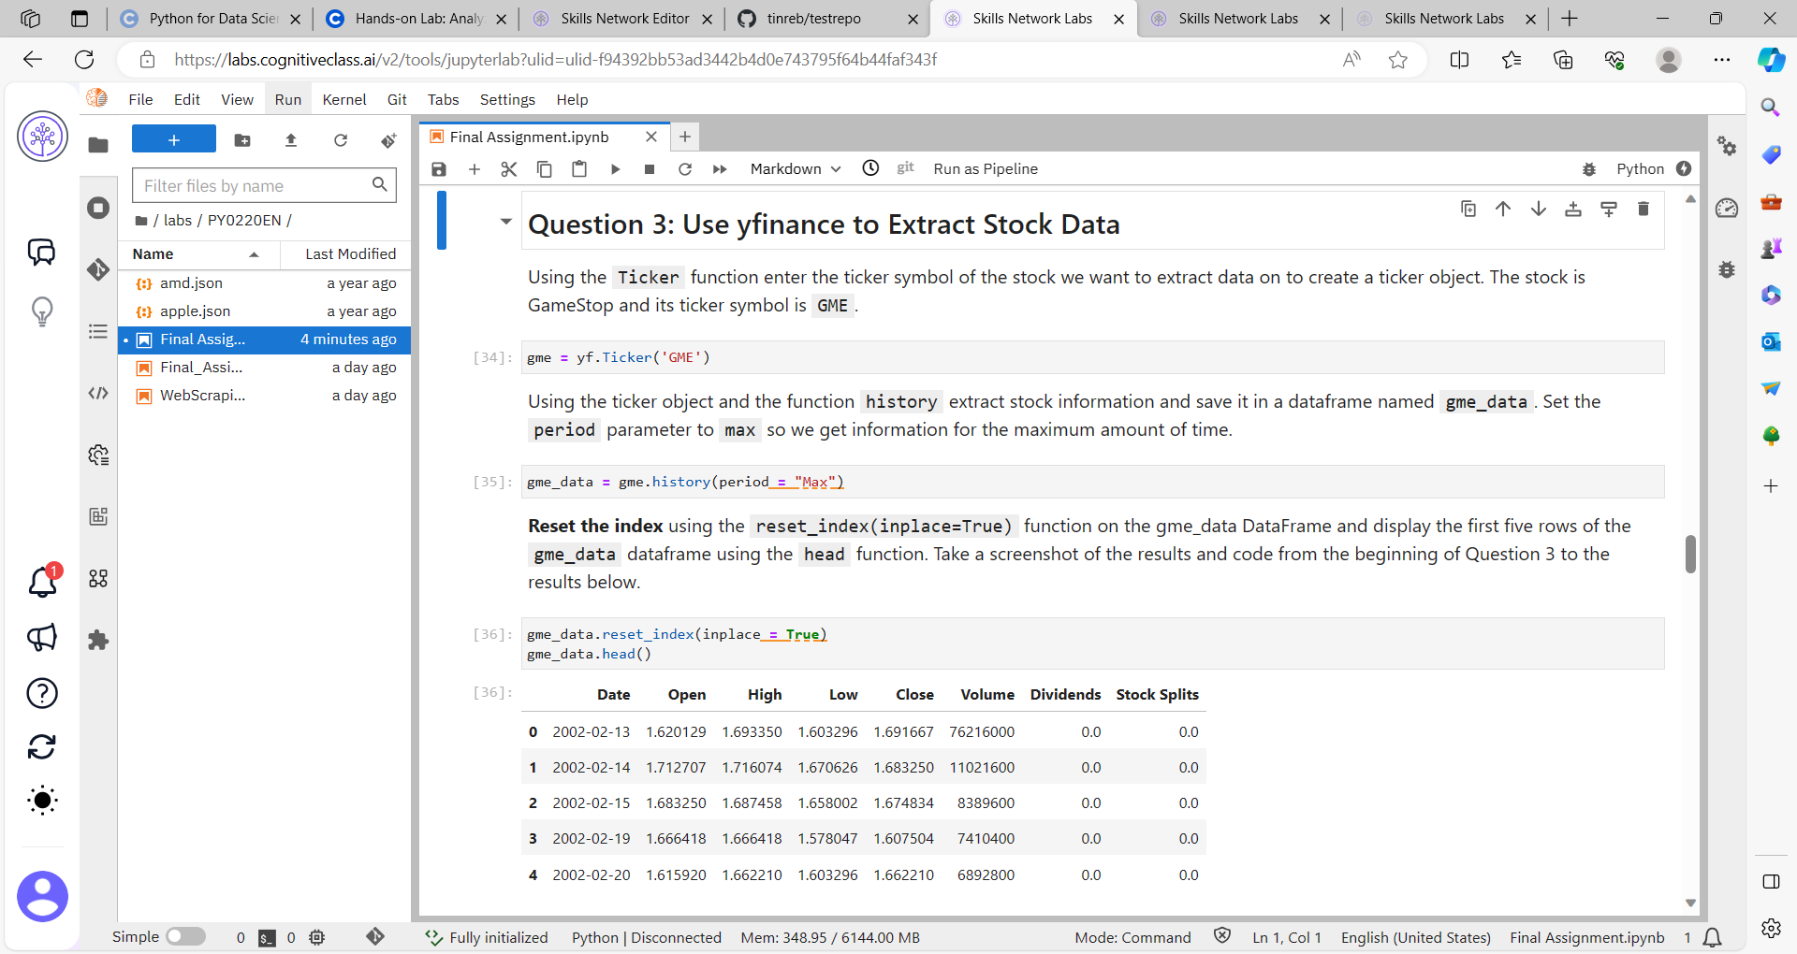

Answer for Question 4: Part 1

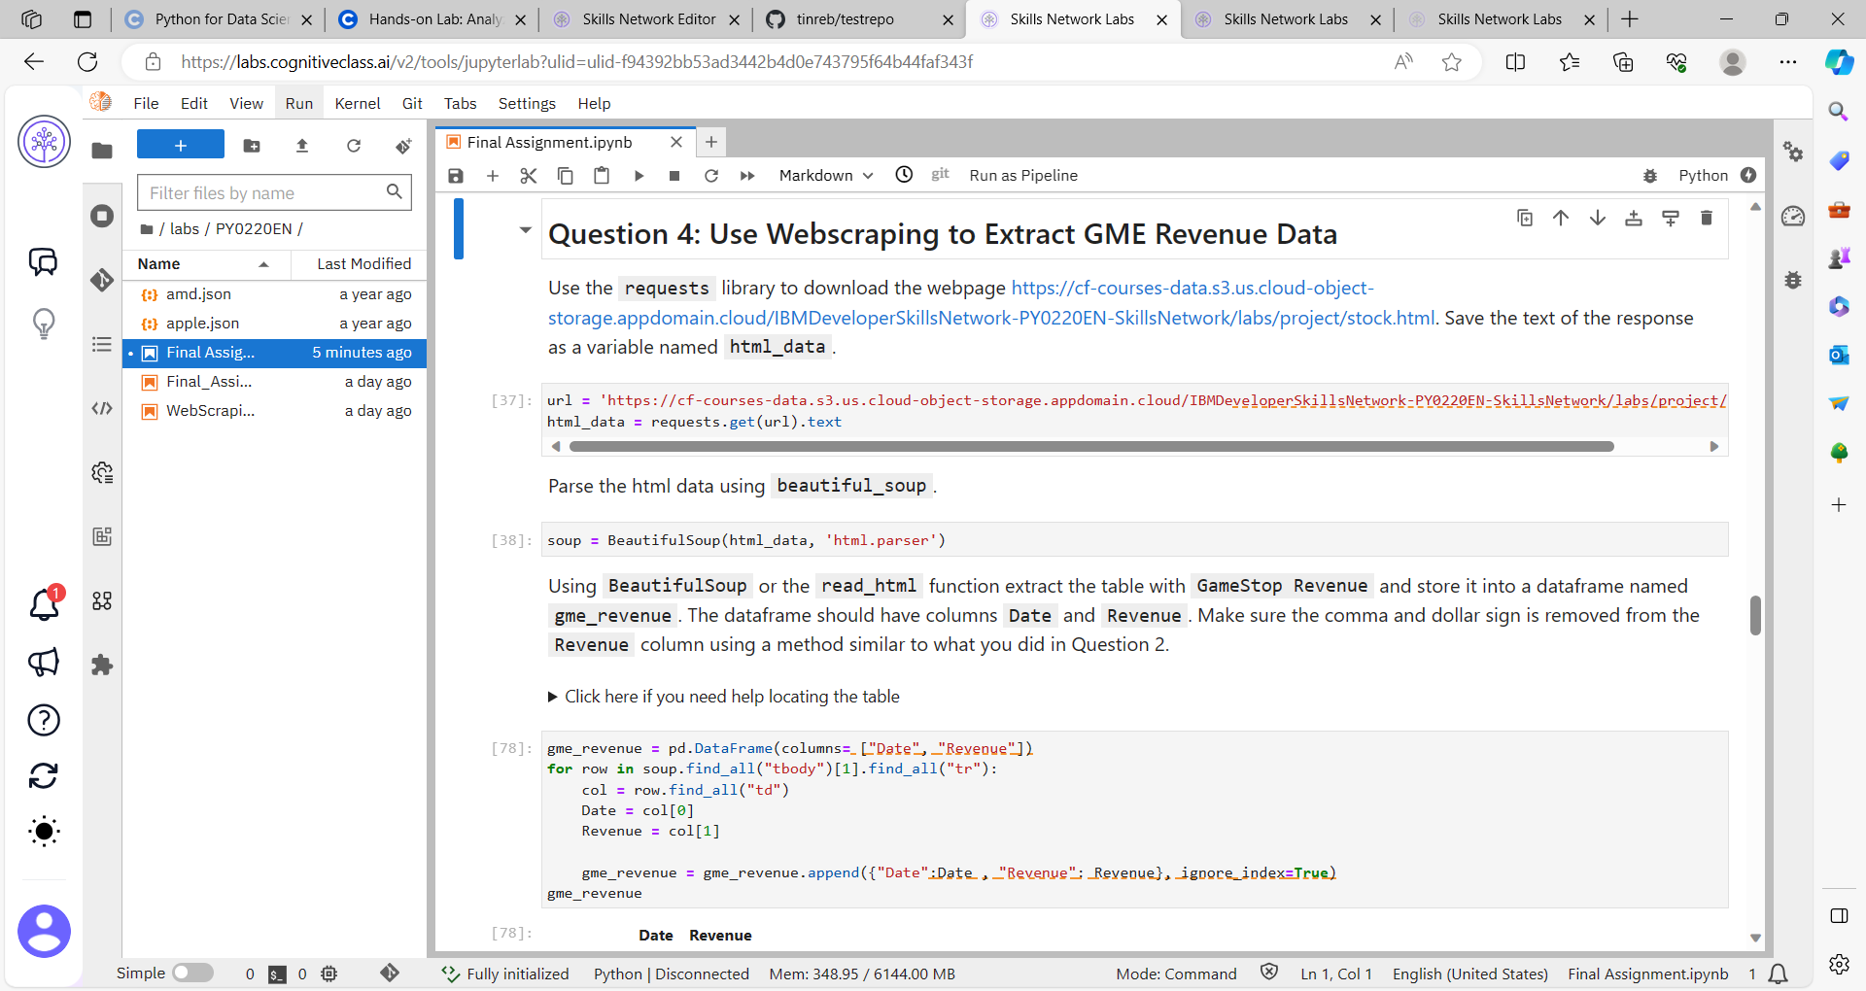

Answer for Question 4: Part 2

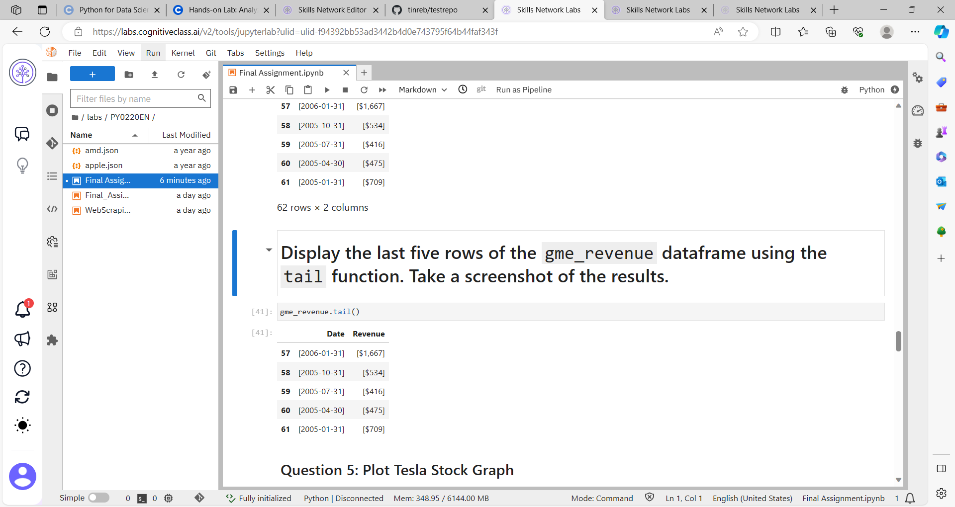

## Answer for Question 5: Plot Tesla Stock Graph:

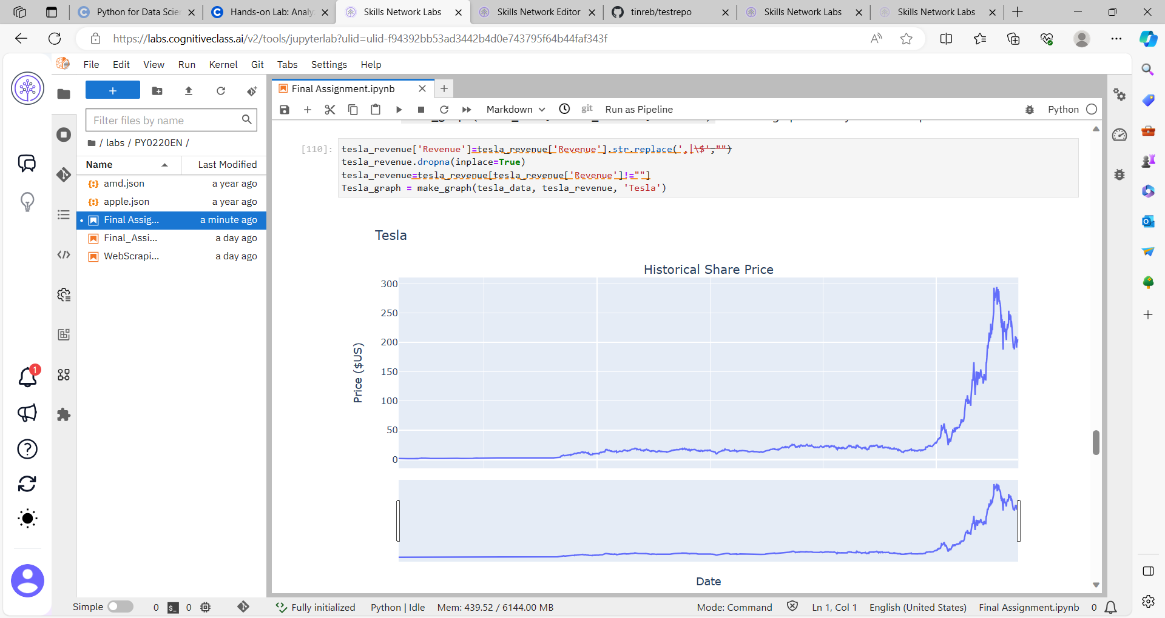

## Answer for Question 6: Plot GameStop Stock Graph

## 